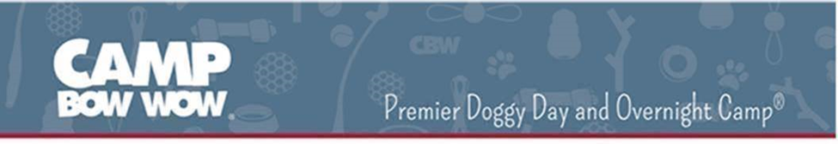
Business Overview and Culture
Camp Bow Wow® is North America’s largest pet care franchise. The $100+ million-dollar company, which ranked #1 in the pet category on the Entrepreneur Franchise 500 list for the last three consecutive years and was named in Entrepreneur’s 2017 and 2018 Best of the Best Lists, proudly offers dogs a safe place to play while simultaneously providing socialization, exercise, and TLC from certified Camp Counselors. With over 160 locations, dogs visit a Camp Bow Wow more than 3 million times a year where they enjoy our premier doggy day care, boarding, and training services. Come work at our fun, high-energy company, and be a part of creating a better world for pets while achieving our vision of Happy Healthy Pets, Happy Healthy People!
We are also committed to giving back to the communities we serve by helping dogs in need through our Bow Wow Buddies Foundation! Learn more about our charitable efforts by visiting www.bowwowbuddies.com.
Camp Bow Wow® is a subsidiary of VCA, Inc. VCA is North America’s leading network of veterinary hospitals and is the leading provider of specialty veterinary medicine and post graduate veterinary training.
About the Job
The Marketing and Sales Coordinator (aka Scout) works directly with the Corporate Marketing Team and the local Camp Manager to grow the business of the local Camp through a variety of marketing and sales activities. The Scout serves as the representative of the brand in the community and through various outlets. This role is split evenly between grassroot marketing and in-Camp responsibilities. The Marketing Scout will work to create partnerships with local businesses and non-profits, secure and attend local events to represent the brand, and cold call community partners. The Marketing Scout will also spend time in Camp making sales calls, building customer relationships, implementing marketing programs and promotions, and handling digital marketing and social media activities
Primary Responsibilities
- Create awareness (increase new customers and sales) for Camp Bow Wow through grassroots community marketing, customer referrals and social media.
- Secure and attend marketing events in the local community to educate the public about our services and generate new leads.
- Build mutually beneficial relationships with local vet hospitals, rescues, shelters and businesses.
- Coordinate Camp Bow Wow events and manage vendors to increase business traffic.
- Manage social media presence and use established digital programs to increase brand visibility.
- Track and measure all programs to manage set marketing budget and ensure Camp goals are being met.
- Generate sales and build new customer base through phone and email follow-ups.
Essential Skills
- Self-starter: organized and able to meet deadlines.
- Energetic and outgoing with an upbeat and positive personality.
- Must be able to work individually as well as in a team setting.
- MUST LOVE DOGS!!!
Requirements
- 2 year of sales or marketing experience required.
- Must have a high school diploma or equivalent.
- Must be authorized to work in the United States.
- Must have reliable transportation.
- Must have a valid driver's license.
Reporting
- Corporate Marketing Manager
Availability
Full time, hourly position. This position requires a commitment of 40 hours per week with a split between in-Camp responsibilities and grassroot marketing activities. The Camp Scout position is ideal for an energetic individual with sales or marketing experience. This individual must be a self-initiator, self-motivated and be accountable through tracking and communication
Equal Opportunity Employer
Camp Bow Wow is an Equal Opportunity Employer (EOE). Qualified applicants are considered for employment without regard to age, race, color, religion, sex, national origin, sexual orientation, disability, or veteran status. If you need assistance or an accommodation during the application process because of a disability, it is available upon request. The company is pleased to provide such assistance, and no applicant will be penalized as a result of such a request.

